Analyzing Relations Name _________________________________
Graph and analyze each of the following
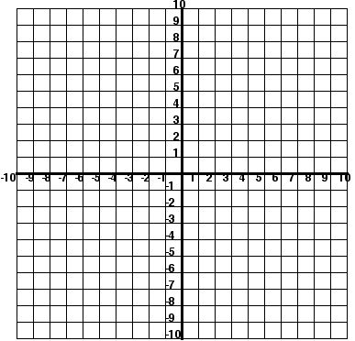
X | y
-4 | 0
-2 | 2
2 | 4
4 | 6
6 | 8
8 | 10
Discrete or continuous?____________
Linear vs non-linear? ______________
X intercept? __________
Y intercept? __________
Domain? _______________________
Range ? ________________________
Function (yes or no)? ______________

X | y
-3 | 9
-2 | 4
-1 | 1
0 | 0
1 | 1
2 | 4
3 | 9
Discrete or continuous?____________
Linear vs non-linear? ______________
X intercept? ________
Y intercept? ________
Domain? _______________________
Range ? ________________________
Function (yes or no)? ______________

Graph and analyze each of the following
- $y=2x-4$
X | y
-2
0
2
Discrete or continuous?____________
Linear vs non-linear? ______________
X intercept? _______
Y intercept? _______
Domain? _______________________
Range ? ________________________
Function (yes or no)? ______________

- $2x+y=6$
X | y
Discrete or continuous?____________
Linear vs non-linear? ______________
X intercept? __________
Y intercept? __________
Domain? _______________________
Range ? ________________________
Function (yes or no)? ______________

